Cyber Security Executive Summary

Table of Contents:

Introduction section

Network Devices Information

Information Collection Methodology

References and Citation

Introduction section
My name is Violet Figueroa. I am a Cybersecurity Analyst. I have been tasked to retrieve information on the Windows11, LinuxServer1, and KaliOpenVas virtual machines for this.

Network Devices Information
Machine designation: Windows11
Device Host Name: WINDOWS11-DESKT
IP Address: 10.0.2.1/24
MAC address: 08:00:27:CB:20:4A
Operating System & version: Windows 11 Home 23H2 (nmap identifies it as window 10 1703)
Open ports with associated services:
- 53/tcp open domain PowerDNS Recursor
ARP Ping Scan elapsed time:1.92s elapsed (255 total hosts)

Machine designation: LinuxServer1
Device Host Name: linux-server
IP Address: 10.0.2.15/24
MAC address: 08:00:27:dd:d8:f8
Operating System & version: Ubuntu 22.04.3
Open ports with associated services
- 3306/tcp open mysql MySQL 8.0.37-0ubuntu0.22.04.3
ARP Ping Scan elapsed time: 1.95s elapsed (255 total hosts)

Machine designation: KaliOpenVas
Device Host Name (ex. DESKTOP-JE9II55, etc): kali
IP Address: 10.0.2.8/24
MAC address: 08:00:27:1b:76:b0
Operating System & version: Kali Linux 2024.2 (Rolling Release)
Open ports with associated services: None found
ARP Ping Scan elapsed time: 1.97s elapsed (255 total hosts)

Information Collection Methodology:
I started by turning on each of the virtual machines. I used ```ipconfig``` on the windows 11 machine and learned its IP address. For the Linux Server Machine and Kali Linux machine, i used ```ip a``` to determine each of their IP addresses. From this, I was able to confirm that all 3 machines were in the 10.0.2.[0-255] IP address range.
I started by opening Wireshark and nmap on my Kali Linux VM. I turned on Wireshark network traffic capture. I ran the following nmap command using Zenmap:
nmap -T4 -A -v 10.0.2.0/24
This scan searched the virtual network and detected the 3 machines that were in the scope of the assignment. However, it also detected local services running on my personal devices that were outside the scope of the assignment. After confirming in an assistance request that the scope was only the 3 machines, I ran intensive scans on each of the 3 machines inside the scope 1 at a time.
I started with the Windows 11 virtual machine
nmap -T4 -A -v 10.0.2.1/24
Device Host Name, WINDOWS11-DESKT, was located in the nmap scan in the HTTP header
```http-title: Welcome | PRTG Network Monitor (WINDOWS11-DESKT)```

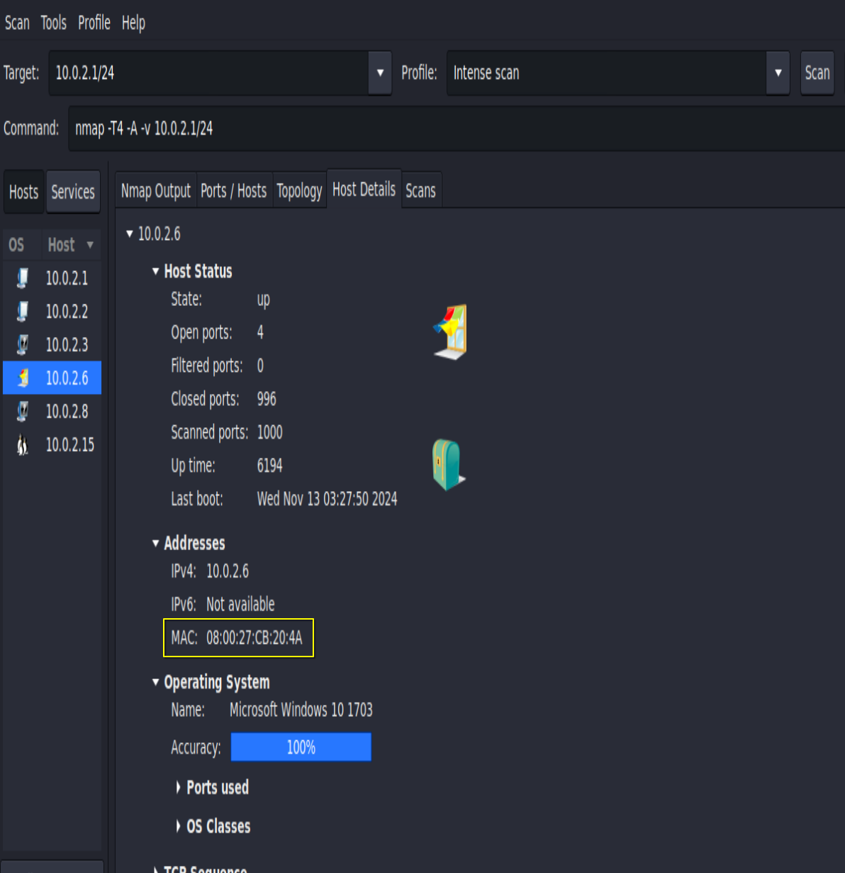
MAC-Address was listed under the host details tab of the Zenmap GUI, in the addresses section.

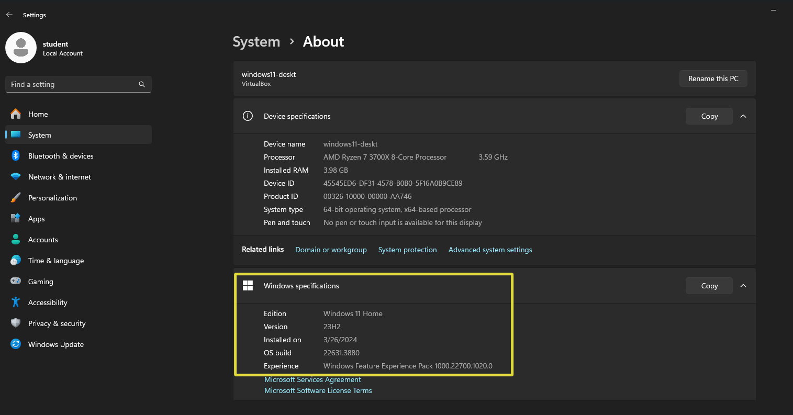
The nmap scan host details identifies it as window 10 1703, but checking the machine device information lists it as Windows 11 Home 23H2.
The ARP ping scan information was located in the start of the nmap output.

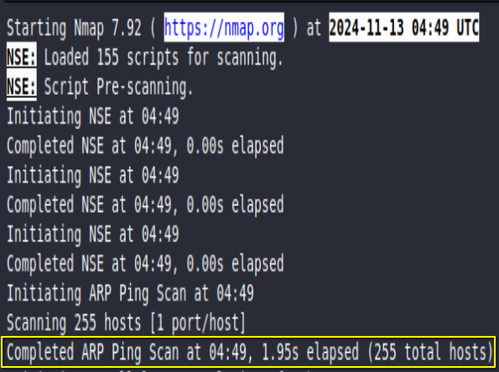
The arp ping scan information was located in the start of the nmap output.

I used the same methods to acquire the information on the Linux Server.
For the Kali server, I used several Linux commands, such as ```ip a``` based on the linux cheat sheet that gave the information, since the nmap scans did not show the information as it was the machine running the scans.

The Machine designation was tricky. The Larry AI wasn’t sure when I asked it, but it guessed that this is referring to the VM Names, so I have listed those for each machine.

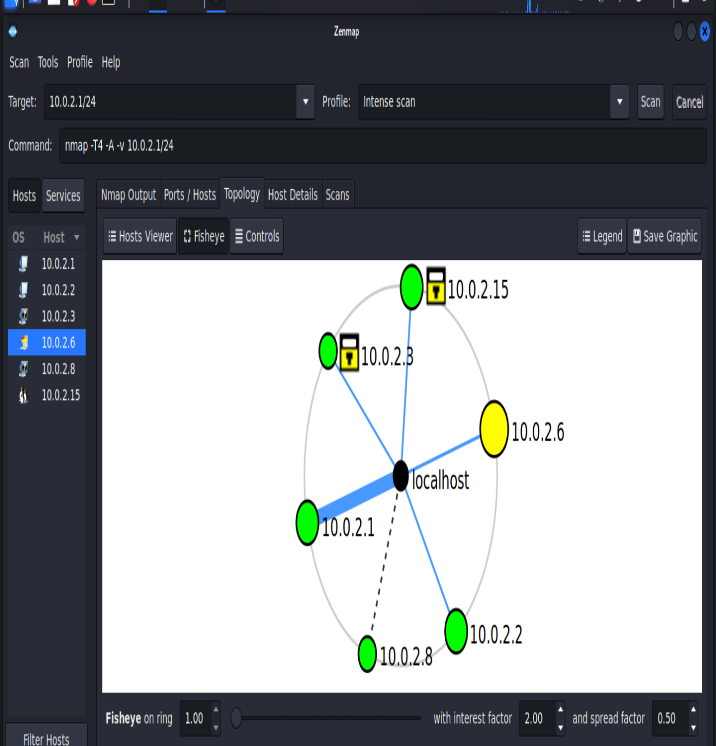
Here is the topology map that was generated based on the scans of the network. There were 3 other unknown services that seem to be connected to the windows 11 machine but otherwise are different services from the 3 main virtual machines. My recommendation is to close those services if they are not needed. I also recommend isolating each machine from each other as independent machines unless they need to be used together.

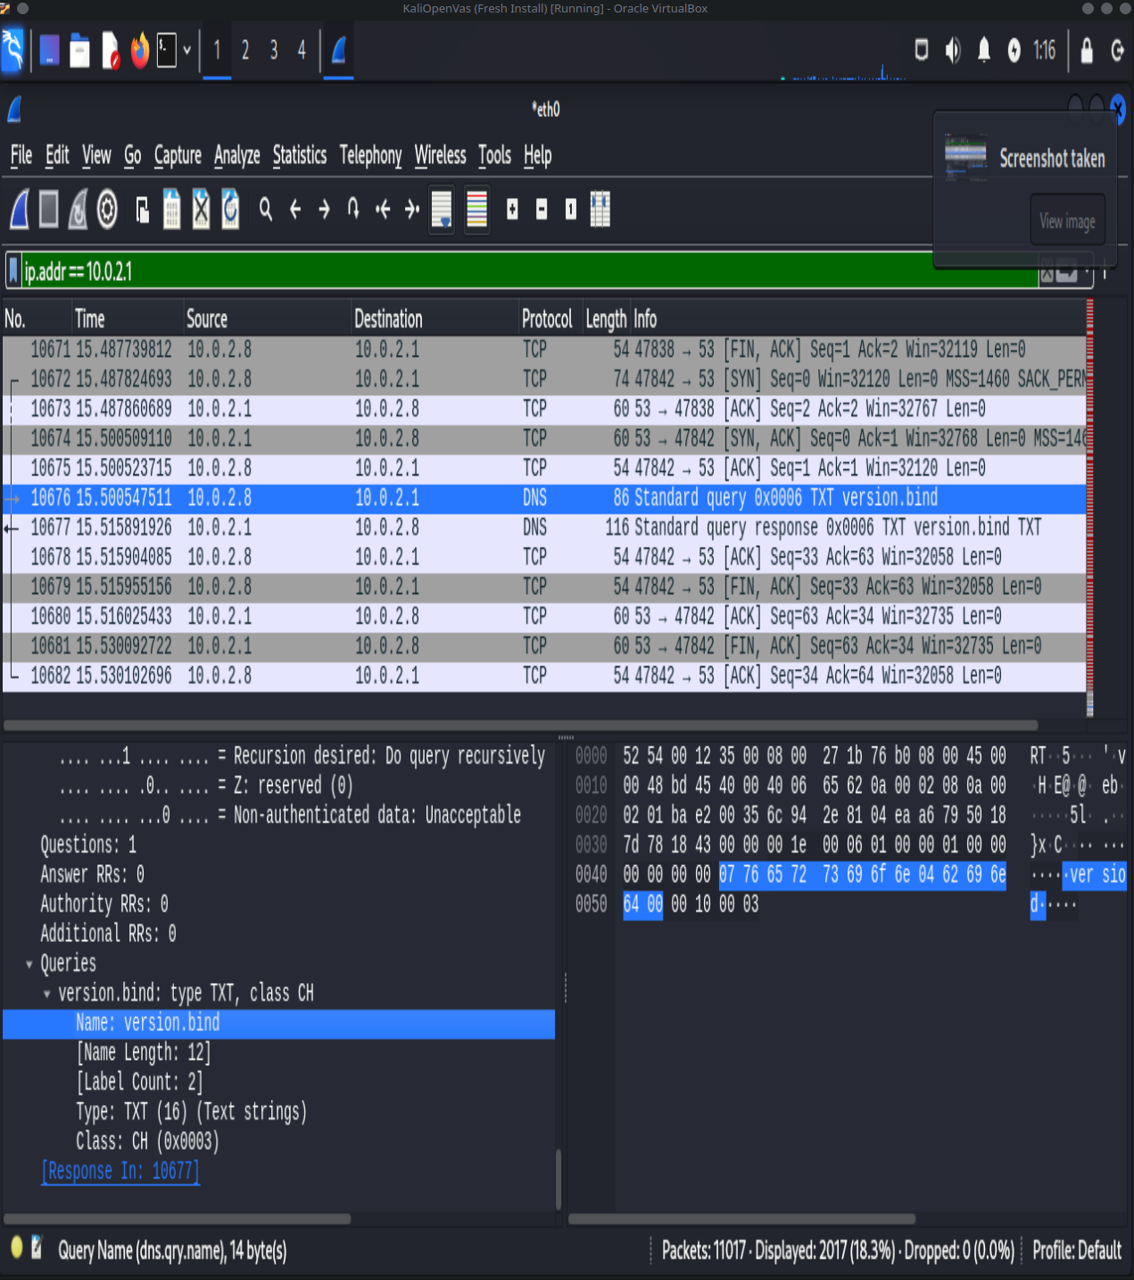
The screenshot of wireshark here shows the windows nmap scan was primarily done using TCP on the Network Access Layer. The Query of the Domain Name System was done at the Nettwork Layer.

References and Citation
This report was prepared using guidance and materials provided through the course lectures and web pages from Lighthouse Labs.

Some of the methodology was guided by Larry AI.

